The Impact of COVID-19 on Water Usage in the City of Long Beach

Prepared by Anh Nguyen

# Table of Content

1. Objective
2. Data exploration and preparation
   1. Data challenges
   2. Data reformat process
   3. Water use adjustments solution
3. Key findings

## Objective

In March 2020, a Safer at Home Order was declared in Long Beach in response to the

COVID-19 pandemic. This led to the closing of many businesses and a large portion of

the population staying at home. The purpose of this study is to understand the impacts of

the COVID-19 pandemic on water use.

## Data exploration and preparation

The data consists of 2018, 2019 and 2020 water use of approximately 90,000 accounts in Long Beach along with details on writing dates, rate, and lapse between writing dates.

### Data challenges

1. A challenge with this data set is that meter reads do not only occur on the  
   last day of each month and can occur on any day of the month. A meter  
   read can happen during the middle of a month, July 15 for example, and  
   therefore the water usage associated with that read is representative of the water used between the latter half of June and the first half of July.
2. Similarly, a meter may have a meter read date of July 1. In this case, even though the meter read date is in July, the associated water usage from that read is almost entirely June water use.
3. Some accounts may have a missing “monthly” read, so therefore the next read may be representative of water use for two “months”. An example of this would be an account having a read on July 15, a blank read in August and another read on September 15. In this instance, the water use associated with the September 15 read would be the total water used between July 16 through September 15.

### Data reformat Process

In order to make it easy to query and produce analysis/reports showing a continuous 3-year trend of water use for each individual account, the three separate data sets are joint by account number. In addition, the initial wide formatted data is converted into the long format.

In particular, the new joint data set is looking as follows



### Water use adjustments solution

As mentioned, the inconsistence in the water write dates makes the monthly water use data fluctuating and hence, it would be hard to produce accurate insights into our analysis on changes in monthly water use due to COVID-19.

To smooth out the trend lines for this time series data, I applied an averaging method with a window of 3 on the monthly use data. This process assumes all accounts were written in the middle of the month. For example, to calculate water use on 12/2020, you multiply 12/2020 data by ¼, the preceding month my ½, and 10/2020 by ¼.

**Water Use (t) = ¼ *water use (t) + ½ * water use (t-1) + ¼ * water use(t-2)**

This could help spread out the water use data for missing writing dates.

A downside of this method is the first two months of 2018 have 0 as their records because the preceding months are out of scope for this dataset.

## Key findings

1. In general, the total water use behaves similarly among the three years. We see an upward trend from January to September and then it is slightly going down toward yearend.

In addition, 2018 has the high volume of water use for most month, there is no significant change from 2019 to 2020 except that there is a big drop in 04/2020, just right after the pandemic was announced.

Looking at the aggregate usage of water across all rate types, there is barely a dramatic change in the monthly water use since COVID-19 was informed.

|  |  |  |  |
| --- | --- | --- | --- |
| **Month** | **2018** | **2019** | **2020** |
| January | 0 | 1543256 | 1538086 |
| February | 0 | 1423963 | 1565971 |
| March | 1489808 | 1407079 | 1469394 |
| April | 1601152 | 1611207 | 1385446 |
| May | 1744172 | 1668633 | 1660669 |
| June | 1853648 | 1756566 | 1821897 |
| July | 1972809 | 1875511 | 1927986 |
| August | 1946276 | 1884643 | 1879610 |
| September | 1986940 | 1961627 | 1978357 |
| October | 1799073 | 1823159 | 1828637 |
| November | 1798930 | 1781024 | 1759743 |
| December | 1711134 | 1668495 | 1771795 |

Total Monthy Water Use by Year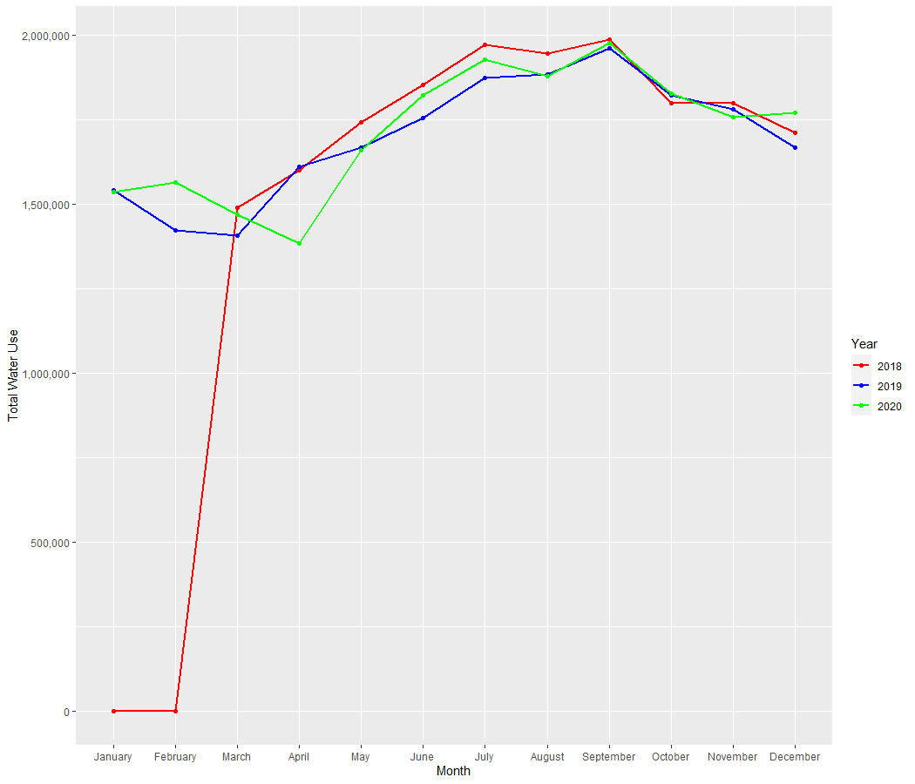

1. In terms of water use by rate type, COVID-19 has caused a more significant impact.

There is a downtrend in Commercial and Irrigation rate type whereas residential types do not change much.

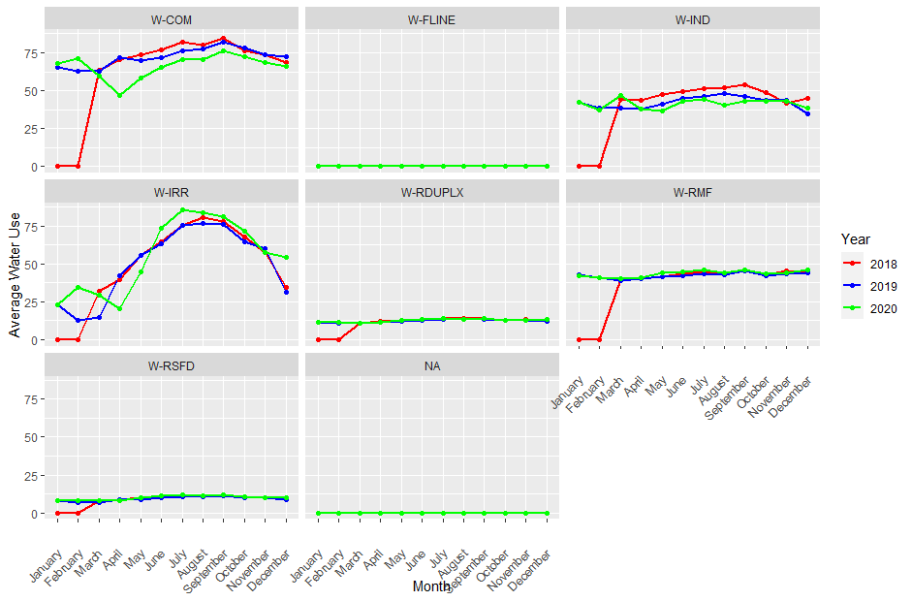

|  |  |  |  |
| --- | --- | --- | --- |
| **Row Labels** | **2018** | **2019** | **2020** |
| **W-COM** | **763.1443266** | **871.1030552** | **802.5621883** |
| January | 0 | 65.92100681 | 68.62156074 |
| February | 0 | 63.49137249 | 71.70635559 |
| March | 63.83895853 | 63.56767453 | 60.34465004 |
| April | 71.03359049 | 72.30647459 | 47.06017699 |
| May | 74.16473803 | 70.13281621 | 58.9842317 |
| June | 77.70106075 | 72.51812569 | 66.20305712 |
| July | 82.31195757 | 76.68972614 | 71.00337892 |
| August | 81.1444873 | 77.76776951 | 71.99758648 |
| September | 84.92478303 | 82.89773627 | 78.02461786 |
| October | 77.20475731 | 78.59411113 | 73.26934835 |
| November | 74.36547734 | 74.54551211 | 69.14384553 |
| December | 76.45451623 | 72.67072978 | 66.20337892 |
| **W-FLINE** | **0** |  | **0** |
| **W-IND** | **479.9449153** | **511.4190871** | **500.0255319** |
| January | 0 | 42.89626556 | 42.83404255 |
| February | 0 | 38.86307054 | 37.6 |
| March | 44.35169492 | 40.39419087 | 47.21276596 |
| April | 43.66101695 | 38.56846473 | 37.95319149 |
| May | 47.60169492 | 41.60995851 | 36.83404255 |
| June | 49.77118644 | 45.21991701 | 43.29787234 |
| July | 51.68644068 | 46.3526971 | 44.47659574 |
| August | 52.47033898 | 48.19502075 | 40.64680851 |
| September | 53.83898305 | 46.57261411 | 43.27659574 |
| October | 49.21186441 | 43.73858921 | 43.57446809 |
| November | 42.13559322 | 43.82987552 | 43.2212766 |
| December | 45.21610169 | 35.17842324 | 39.09787234 |
| **W-IRR** | **588.6567944** | **603.2149613** | **664.2179156** |
| January | 0 | 23.12037833 | 23.50645995 |
| February | 0 | 12.80825451 | 35.08440999 |
| March | 32.31968641 | 14.88907997 | 29.79758829 |
| April | 39.41463415 | 42.40412726 | 20.63652024 |
| May | 55.55139373 | 55.8116939 | 45.34280792 |
| June | 65.18989547 | 63.82287188 | 73.65374677 |
| July | 76.00958188 | 75.79621668 | 86.22652885 |
| August | 81.39372822 | 77.63800516 | 84.92764858 |
| September | 78.06097561 | 76.81255374 | 81.3583118 |
| October | 67.88937282 | 65.8383491 | 71.60809647 |
| November | 58.37020906 | 60.67927773 | 57.65633075 |
| December | 34.45731707 | 33.59415305 | 54.41946598 |
| **W-RDUPLX** | **130.1454997** | **148.1012315** | **154.8881867** |
| January | 0 | 11.68571429 | 11.52345649 |
| February | 0 | 10.8885468 | 11.39244045 |
| March | 11.17554314 | 10.67093596 | 11.1181332 |
| April | 11.94562384 | 11.64445813 | 11.64657268 |
| May | 12.72340161 | 11.93608374 | 13.19628099 |
| June | 13.41738051 | 12.69002463 | 13.79557608 |
| July | 14.37653631 | 13.48928571 | 14.24319397 |
| August | 13.91247672 | 13.34359606 | 13.76798736 |
| September | 13.93978895 | 13.70665025 | 14.30274672 |
| October | 12.67721912 | 12.74963054 | 13.17452601 |
| November | 13.32960894 | 12.72807882 | 13.18740885 |
| December | 12.64792055 | 12.5682266 | 13.53986388 |
| **W-RMF** | **435.7135624** | **511.2870631** | **524.7450104** |
| January | 0 | 42.82333941 | 42.17407867 |
| February | 0 | 40.80255094 | 41.05026915 |
| March | 40.01975432 | 39.37692563 | 40.33333333 |
| April | 40.50323705 | 40.52898791 | 41.08935818 |
| May | 42.23688579 | 41.92761305 | 44.1479089 |
| June | 44.07337317 | 42.57304953 | 44.55271222 |
| July | 45.27739044 | 43.76196786 | 46.24612836 |
| August | 44.20816733 | 43.33410634 | 44.22095238 |
| September | 46.05403386 | 45.52658605 | 46.36853002 |
| October | 43.21787849 | 42.86226603 | 43.74964803 |
| November | 45.85491368 | 43.49188339 | 44.57432712 |
| December | 44.26792829 | 44.27778698 | 46.23776398 |
| **W-RSFD** | **101.1469** | **111.4784836** | **118.6981845** |
| January | 0 | 7.945655971 | 7.860159149 |
| February | 0 | 6.945805679 | 8.046541175 |
| March | 7.880916667 | 6.926260459 | 7.859791367 |
| April | 8.657066667 | 8.515661127 | 7.825520746 |
| May | 9.93925 | 9.107440491 | 9.88194189 |
| June | 10.74225 | 9.918575445 | 11.08820088 |
| July | 11.66503333 | 10.87587538 | 11.71092313 |
| August | 11.51478333 | 10.97709467 | 11.31333378 |
| September | 11.48456667 | 11.25170917 | 11.88979906 |
| October | 10.10583333 | 10.28865379 | 10.75285031 |
| November | 9.99075 | 9.989087945 | 10.13368886 |
| December | 9.16645 | 8.736663506 | 10.33543415 |